**Coding Assignment 4**

***Shubham Maheshwari(17EC10055)***

**TASK A)**

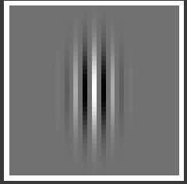

**𝜎 = 3 pw, λ = 4 pw**

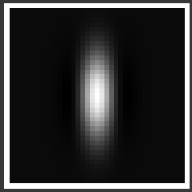

**𝜎 = 3 pw, λ = 20 pw**

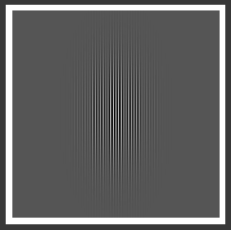

**𝜎 = 20 pw, λ = 3 pw**

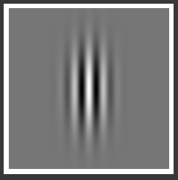

**𝜎 = 18 pw, λ = 20 pw**

**DISCUSSION**

* The gabor filter with lower sigma, about a few pw and high lambda, about many pw {𝜎 = 3 pw, λ = 20 pw} will act as a low pass filter and low sigma leads to general loss of directionality.
* As the sigma is also increased alongside a high wavelength, the directionality in filtering increases. {𝜎 = 18 pw, λ = 20 pw}
* With low lambda or/and higher sigma, the gabor filter tends towards bandpass nature. High sigma gives more directionality along with the band pass nature.

**TASK B)**

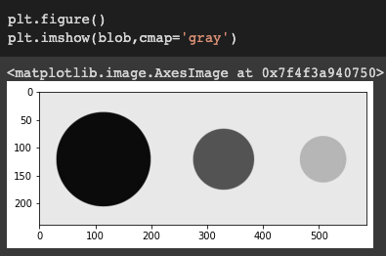

Blobs.tif

i) Gabor Filter : 𝜆 = 5pw, 𝜎 = 3pw, 𝛾 = .5, 𝜃 = 0°

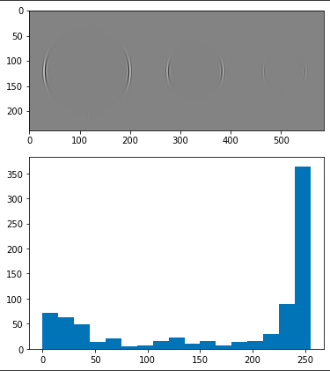

ii) Gabor Filter : 𝜆 = 5pw, 𝜎 = 3pw, 𝛾 = .5, 𝜃 = 45°

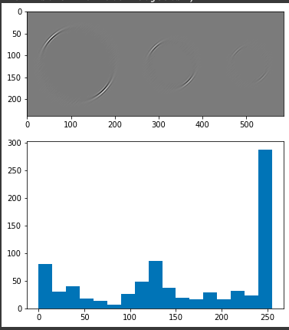

iii) Gabor Filter : 𝜆 = 5pw, 𝜎 = 3pw, 𝛾 = .5, 𝜃 = 90°

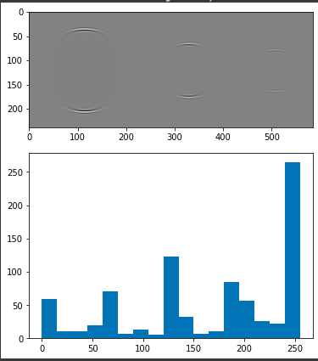

iv) Gabor Filter : 𝜆 = 5pw, 𝜎 = 3pw, 𝛾 = .5, 𝜃 = 135°

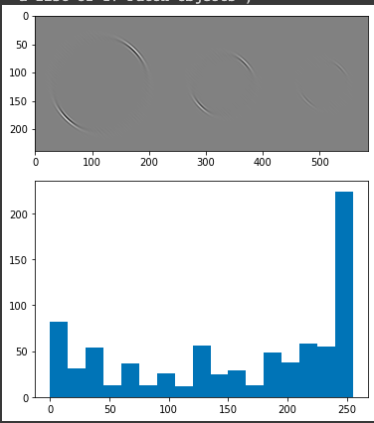

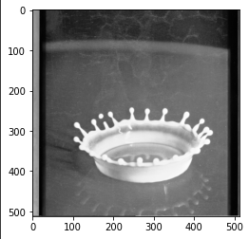

Drop.tif

i) Gabor Filter : 𝜆 = 5pw, 𝜎 = 3pw, 𝛾 = .5, 𝜃 = 0°

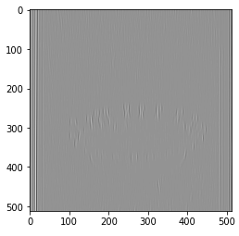

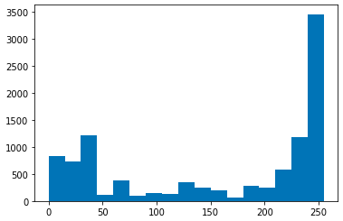

ii) Gabor Filter : 𝜆 = 5pw, 𝜎 = 3pw, 𝛾 = .5, 𝜃 = 45°

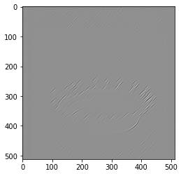

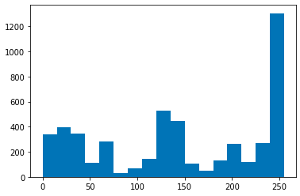

iii) Gabor Filter : 𝜆 = 5pw, 𝜎 = 3pw, 𝛾 = .5, 𝜃 = 90°

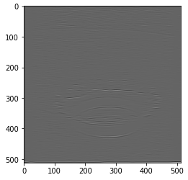

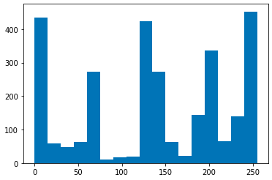

iv) Gabor Filter : 𝜆 = 5pw, 𝜎 = 3pw, 𝛾 = .5, 𝜃 = 135°

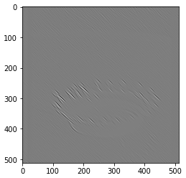

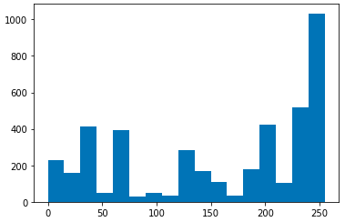

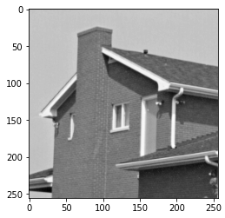

House.tiff

i) Gabor Filter : 𝜆 = 5pw, 𝜎 = 3pw, 𝛾 = .5, 𝜃 = 0°

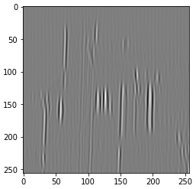

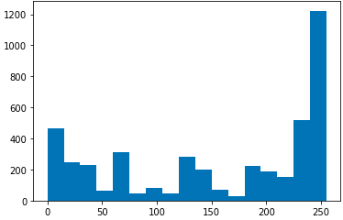

ii) Gabor Filter : 𝜆 = 5pw, 𝜎 = 3pw, 𝛾 = .5, 𝜃 = 45°

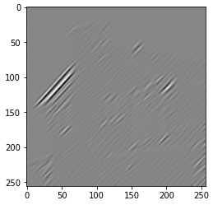

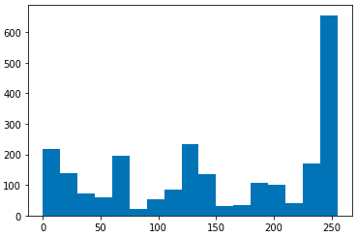

ii) Gabor Filter : 𝜆 = 5pw, 𝜎 = 3pw, 𝛾 = .5, 𝜃 = 90°

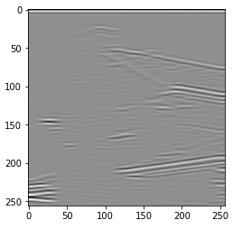

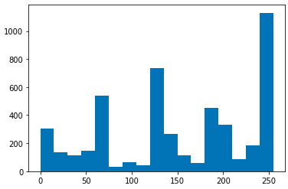

iii) Gabor Filter : 𝜆 = 5pw, 𝜎 = 3pw, 𝛾 = .5, 𝜃 = 135°

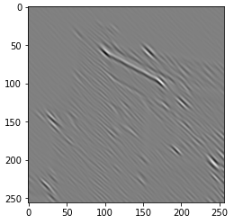

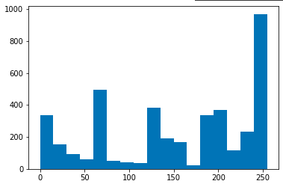

**DISCUSSION**

* All the LBP histograms have their peak at 255 implying that the maximum number of pixels in any orientation in all the images have lesser pixel values compared to each of their 3x3 neighbourhood pixels.
* The application of gabor filters for 𝜃 = {0°,45°,90°,135°}, resulted in the filtering of corresponding specific directional content in localized regions of the image.
* With increase in 𝜃 from 0° to 135° in gabor filters, the count of pixels with the LBP value 255 decreased in all the filtered images resulting in increasing regularity.
* The LBP histograms in the case of House.tiff gave nearly similar distributions for all 4 values of theta in gabor filters indicating regularity in the image pixel values.
* For the image Drop.tif, the LBP histogram for gabor filter output for theta=90° contained several peaks throughout the distribution indicating a unique texture pattern in the gabor filter output when compared to the histograms with thetas 0,45, and 135.

Considering the dominant orientation at a pixel as the orientation corresponding to the maximum absolute value among the 4 Gabor output values at that pixel :

